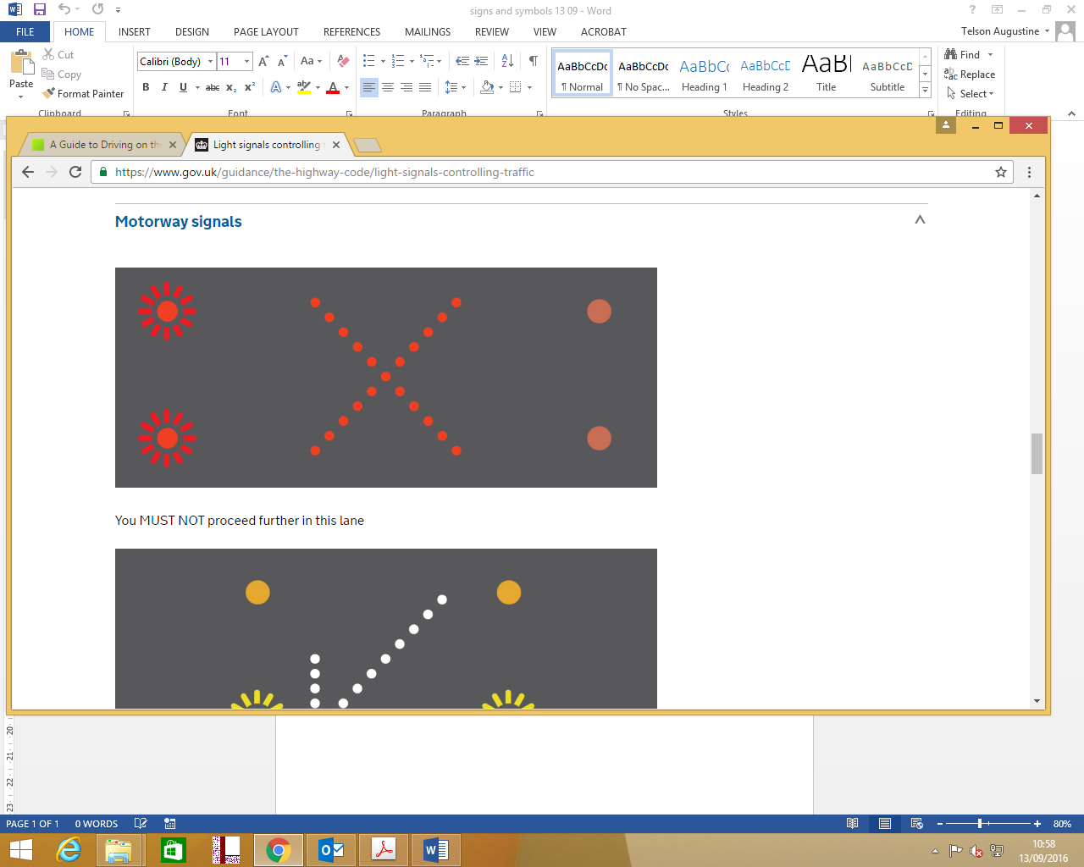

What is the meaning of this symbol on a motorway?

1. You must travel only on this lane
2. You must not travel on this lane
3. Bright sun ahead, difficult to drive

2)

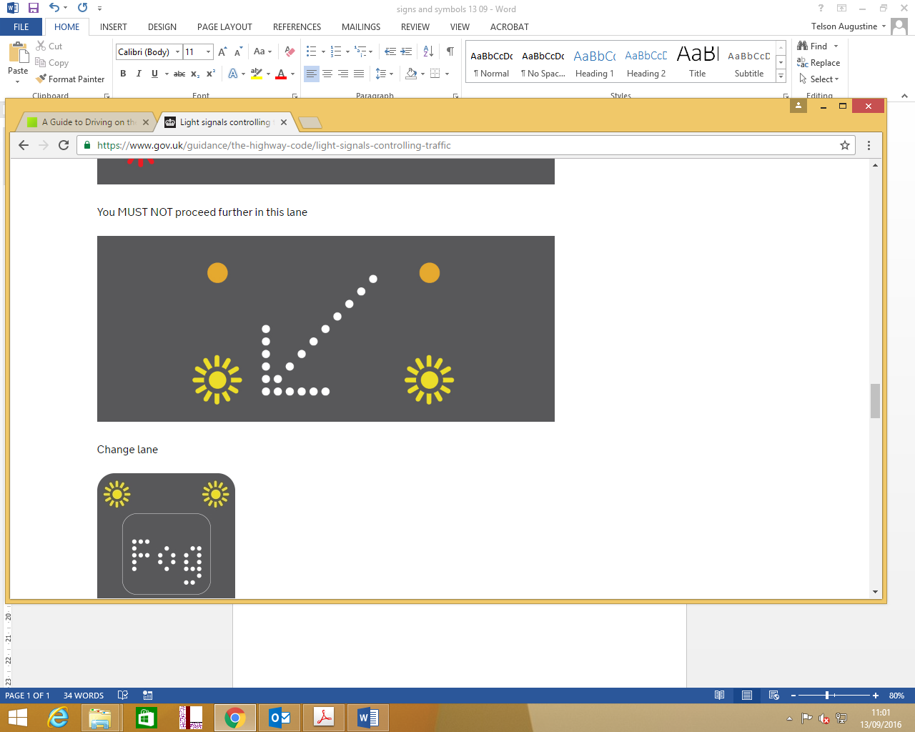

What is the meaning of this sign on the motorway?

1. Change lane
2. Park your car to left side
3. Drive back

3)

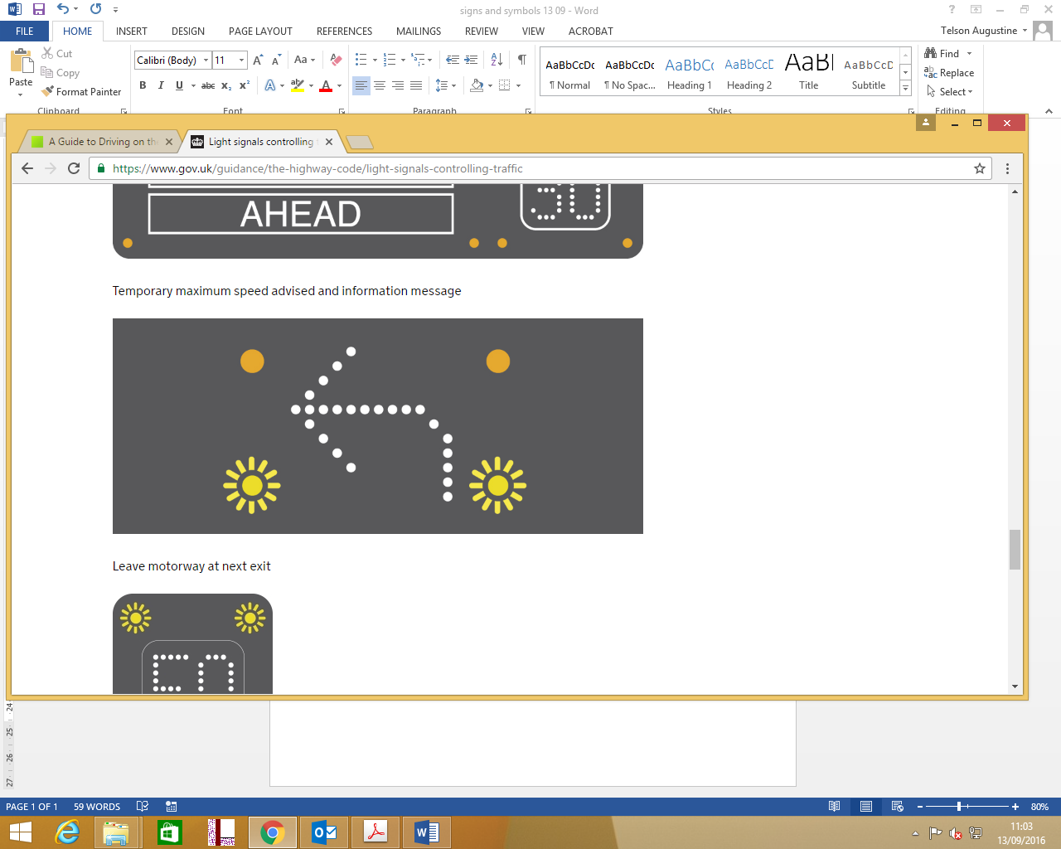

What is the meaning of the sign given above?

1. Leave motorway at next exit
2. Take a left turn on the motorway itself and stop the car
3. Change lane

4)

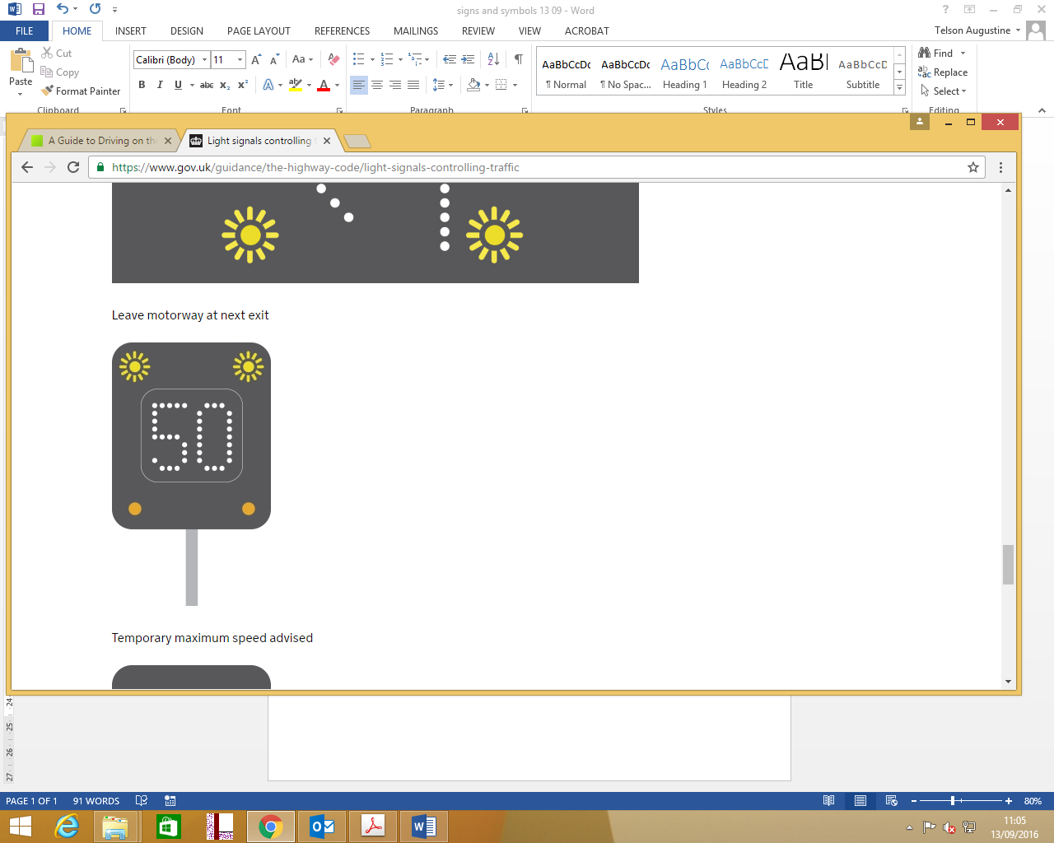

What is the meaning of the sign given above

1. Visibility 50m
2. Maximum speed 50 mph
3. Maximum speed 50 kmph
4. Visibility 50 cars

5)

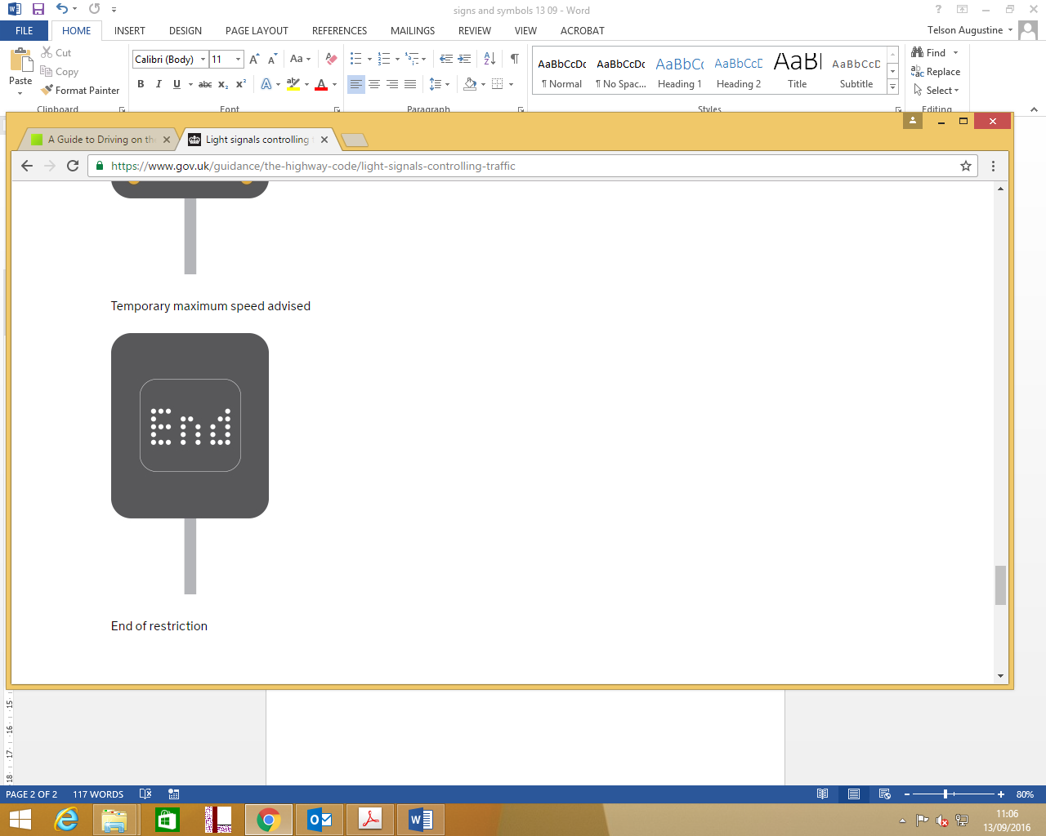

What is the meaning of the above given sign?

1. End of restriction
2. End of motorway
3. End of camera zone
4. End of driving, stop your car

6)

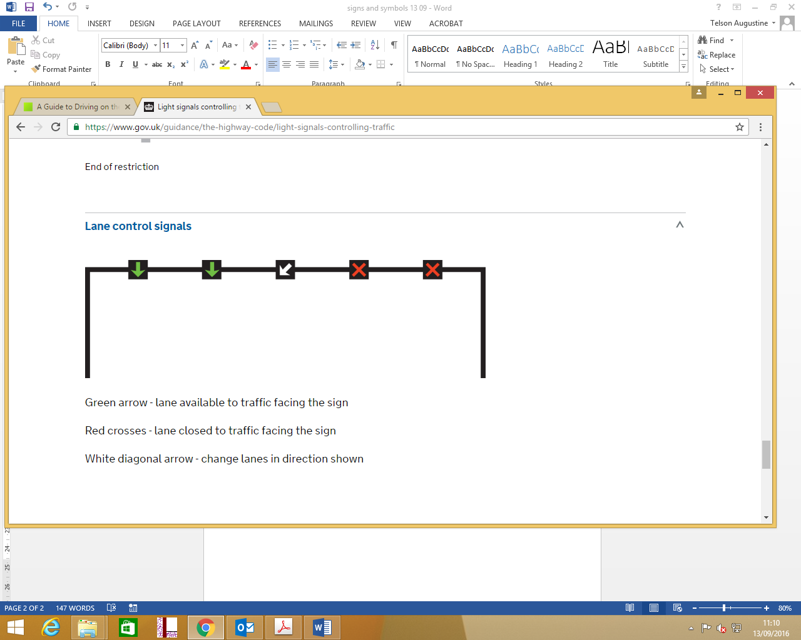

What is the meaning of the green sign?

1. Lane available to traffic facing the sign
2. Lane exiting the motorway
3. Green coloured cars only on the lane
4. Slow down on the lane
5. Drive back on this lane

7)



What is the meaning of the white sign above?

1. Instructing the middle lane vehicles to change lane to left
2. Informing the middle lane vehicles that the right lanes vehicles are coming to the middle lane
3. Middle lane vehicles should stop

8) 

What is the meaning of the red sign given above?

1. Lane closed for traffic facing the sign
2. Stop all vehicles on the lane below the red sign
3. Non stop fast lane, do not stop your vehicles on this lane.

9) If a red light flashes on the left side of the motorway, what is the meaning?

a) you must not go beyond the signal on any lane

b) you must not go beyond the signal on left lane

c) You can drive until you see the next warning sign on top of the motorway

d) Warning that you must reduce speed until you see the next signal

10) If separate signals are not shown, and if a red light flashes on the central lane, what you should do?

a) you must not go beyond the signal on any lane

b) you must not go beyond the signal on left lane

c) You can drive until you see the next warning sign on top of the motorway

d) Warning that you must reduce speed until you see the next signal

11) If separate signals are not shown and then a central reservation signal should be applied to

a) all lanes

b) central lane only

12) If the motorway road ahead is clear, you should always drive on the

a) left lane

b) middle lane

c) lane which comes inside the curve to drive less

13)When can I drive on the hardshoulder

a) Directed by a police/traffric officer in uniform

b) Inorder to avoid the traffic block ahead

c) I am late to reach my work place, and hard shoulder is empty

d) None of the above

14) The right hand lane of the three or more lane motorway can be used by

a) any vehicle drawing a trailer

b) a goods vehicle with a maximum laden weight exceeding 7.5 tonnes

c) a passenger vehicle with a maximum laden weight exceeding 7.5 tonnes constructed or adapted to carry more than eight seated passengers in addition to the driver

d) If you are driving an empty car

15) On a three lane motorway, I want to overtake a middle lane vehicle. Which lane should I use?

a) left lane

b) right lane

c) any lane

16) find the correct sequence of overtaking a vehicle on a motorway

1. check your mirrors
2. take time to judge the speeds correctly
3. make sure that the lane you will be joining is sufficiently clear ahead and behind
4. take a quick sideways glance into the blind spot area to verify the position of a vehicle that may have disappeared from your view in the mirror
5. Remember that traffic may be coming up behind you very quickly. Check all your mirrors carefully. Look out for motorcyclists. When it is safe to do so, signal in plenty of time, then move out
6. ensure you do not cut in on the vehicle you have overtaken
7. Be especially careful at night and in poor visibility when it is harder to judge speed and distance.
8. a, b, c, d, e, f, g
9. d, e, a, b, c, f, g
10. g, e, f, c, a, b, d

17)Can I use hardshoulder for overtaking?

a) yes

b) No

c) Sometimes

18) Can I stop on the hardshoulder to receive or make mobile phone calls?

a) yes

b) No

c) Sometimes

19) My friend stays very next to motorway. There is a short emergency access path to the motorway. It is early morning and all the lanes are almost empty. Can I pick him up on the motorway to save time?

a) yes

b) No

c) May be

20) Can agricultural vehicles use motorway?

a) yes

b) No

21) Can horse riders use motorways?

a) yes

b) no

22) The website address

<https://www.gov.uk/guidance/the-highway-code/motorways-253-to-273>

describes about

1. motorway rules, signals, lane discipline overtaking etc.
2. methods and techniques for motorway construction
3. guidance for motorways planning for government of the UK

23) On leaving the motorway or using a link road between motorways, if you actually drive at 50 mph, you may feel like you are driving at

a) 30 mph

b) 70 mph